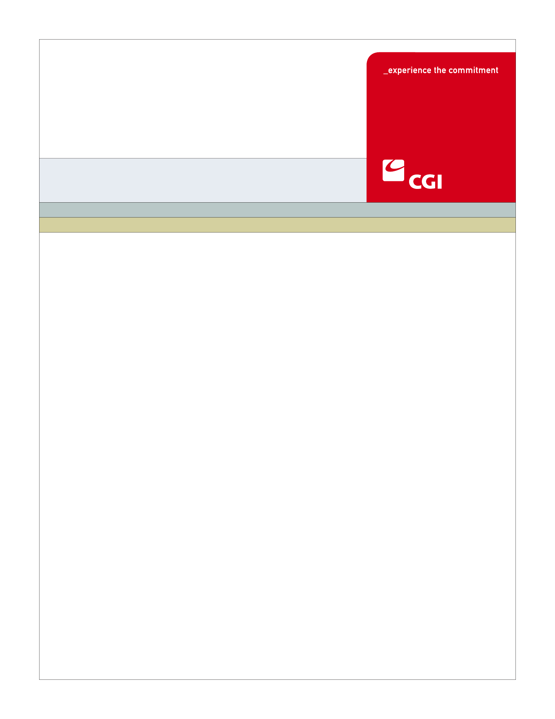

USE
Colorado Health Benefit Exchange (COHBE)
Version 1.3
November 16, 2012
FM-002 Provide Payment Use Case
REVISION HISTORY
Version | Date | Modified By | Description
0.1 | 2012-08-28 | Kevin Sudnik | Created new Use Case document.
0.2 | 2012-09-20 | Kevin Sudnik | Updated Use Case Document post-JAD Discovery
1.0 | 2012-10-02 | Kevin Sudnik | Updated Use Case Document post-JAD Elaboration
1.1 | 2012-10-22 | Kevin Sudnik | Updated Use Case Document post-JAD Verification
1.2 | 2012-11-13 | Kevin Sudnik | Additional updates made for initial payment
1.3 | 2012-11-15 | Ron Frager | Minor edits and formatting

TABLE OF CONTENTS
1 Use Case: Provide Payment 8
1.1 Goal 8
1.2 Brief Description 8
1.3 Requirements Traceability 8
1.4 Primary Actor 9
1.4.1 Exchange 9
1.5 Secondary Actor 9
1.5.1 Employer 9
1.5.2 Back Office 9
1.5.3 Carrier 9
1.5.4 Lock Box 9
1.5.5 Credit Card / EBT / ACH Processing Entity 10
1.6 Pre-Conditions 10
1.7 Successful Post-Conditions 10
1.8 Triggers 10
1.9 Assumptions 10
2 Flow of Events 11
2.1 Basic (Main) Flow – Provide Payment 12
2.1.1 Is This Initial Payment? 13
2.1.2 Calculates and Sends Bill for Aggregated Monthly Premiums or Initial Payment 13
2.1.3 Receives Bill for Aggregated Monthly Premium Payment Due 13
2.1.4 Is Recurring Payment Authorized? 13
2.1.5 Initiate Funds Transfer for Monthly Premium Balance Due or Initial Payment 13
2.1.6 Process Credit Card / EBT / ACH Transaction 13
2.1.7 Record Payment 13
2.1.8 Reconcile Enrollment and Payment 13
2.1.9 Was Payment Made Successfully? 14
2.1.10 Reconcile Invoice 14
2.1.11 Was Payment Greater than or Equal to the Amount Due? 14
2.1.12 Is This Initial Payment? 14
2.1.13 Advance Paid-Through Date 14
2.1.14 Calculates and Divides Payments for Carriers 14
2.1.15 Deducts User and Administrative Fees and COHBE Commission 14
2.1.16 Sends Payments to Carriers 14
2.1.17 Receives Payment 14
2.1.18 Receives Payment 15
2.1.19 Receives Payment 15
2.1.20 Is This an Overpayment? 15
2.1.21 Was Payment Made on Time? 15
2.1.22 Manage Broker Commission 15
2.1.23 Financial Data 15
2.1.24 Next Steps 15
3 Alternate Flows 15
3.1 Has Payment Information Been Provided? 15
3.1.1 Has Payment Information Been Provided? 16
3.2 Employer Provides One-Time Automatic Payment 16
3.2.1 Is Employer Going to Provide Payment? 16
3.2.2 Employer Provides One-Time Payment 16
3.2.3 Is This a Manual Payment? 16
3.3 Employer Provides One-Time Manual Payment to the Lock Box 16
3.3.1 Was Payment Sent to the Back Office? 16
3.3.2 Receives Payment 16
3.4 Employer Sends One-Time Manual Payment to the Back Office 16
3.4.1 Forwards Payment to the Lock Box 17
3.5 Overpayment Process 17
3.5.1 Overpayment Process 17
4 Exception Flows 17
4.1 Delinquent Payment Process 17
4.1.1 Delinquent Payments Use Case 17
5 Specifications 17
5.1 Business Rules 17
5.1.1 Calculate and Send Aggregated Invoice 17
5.1.2 Initiate Recurring Payment 18
5.1.3 Record Payment 18
5.1.4 Reconcile Invoice 18
5.1.5 Determine if Employer Payment is Acceptable 18
5.1.6 Calculate and Distribute Payments to Carriers 18
5.1.7 Determine if Payment was an Overpayment 18
5.1.8 Determine if the Payment was Made On Time 19
5.2 Process Rules 19
5.2.1 Is Recurring Payment Authorized? 19
5.2.2 Was Payment Made Successfully? 19
5.2.3 Was Payment Greater than or Equal to Amount Due? 19
5.2.4 Is This an Overpayment? 20
5.2.5 Was Payment Made on Time? 20
5.2.6 Is This Initial Payment? 20
5.2.7 Has Payment Information Been Provided? 20
5.2.8 Is This Initial Payment? 20
5.3 Workflow 21
5.3.1 Forward Manual Payment 21
5.4 UI Screen Details 21
5.4.1 hCentive Payment Screen 21
5.5 Communications 21
5.5.1 Imaging Requirements 21
5.5.2 Form Requirements 21
5.5.3 Notices Requirements 21
5.5.4 Other Communication Requirements 21
5.6 Interfaces 21
5.7 Reporting 22
5.8 User Security 22
5.9 Activity Log and Audit Trail 22
6 Future Release Notes 22
7 Appendix A - Glossary 23

Use Case: Provide Payment

Goal
The goal of this Use Case is for Employers to make an initial payment as well as ongoing monthly premiums to the Exchange that are then distributed to Carriers.
This Use Case completes successfully when all Carriers have received and processed payments in full from the Exchange on behalf of Employers.

Brief Description
During Submit SHOP Application, the Employer may specify its payment method for initial payment as well as preferred payment method if it would like to set up recurring payments. For ongoing payments, after coverage for Employees has started, the first billing cycle will run and the Exchange will calculate and send an aggregated invoice for the premium payment due to all Carriers for that month to the Employer. For initial payment, the Exchange will initiate the funds transfer if the Employer has provided its payment information. Otherwise, the Exchange will send the Employer a bill for the initial payment owed. Once payment has been received by the Exchange, the Exchange will deduct user fees, administrative fees and COHBE commissions and then divide up and distribute the premium payment to the Carriers. For ongoing payment, if the Employer provided an acceptable payment, the Exchange will advance the Employer’s paid-through date. The Exchange will also determine if the Employer over paid and, if so, will handle the overpayment accordingly. All financial transactions will be recorded in the financial data store.

Requirements Traceability
The following requirements are covered within this Use Case:
- FM02: The Exchange shall distribute payments to the applicable Carriers.
- FM04: The Exchange will allow the application of payments received from SHOP Employers to be processed both manually and in an automated fashion. The Exchange will allow payments to be collected in a variety of ways (e.g. lockbox, ACH, credit card, Paypal).
- FM06: The SHOP Exchange will provide Administrative Fee Processing (the calculation of fees due to COHBE based on the rules configured).
- FM07: The SHOP Exchange will support identification of delinquent payments (Non-Suffcient Funds, late or not received) from an Employer resulting in action that could impact eligibility and/or correspondence to be generated.
- FM10: The Exchange back office will manage all SHOP billing, payment processing including refunds, and notifications.
- FM15: The Exchange will provide the ability to manually and automatically generate and send financial correspondence (e.g. non-payment and rate changes) to Employers, employees and individuals. (Rate changes are not being addressed in this use case)
- SH061: The System shall enable premium aggregation for Employers such that the Employer only writes one monthly check for premiums.

Primary Actor

Exchange
The Exchange is a primary actor in this Use Case. When the Use Case is triggered by the Submit SHOP Application Use Case or when a new billing cycle begins, the Exchange will determine if the payment owed is for an initial payment. The Exchange will then calculate and send a bill to the Employer in cases where the Employer has not provided its payment information for initial payment or if recurring payment has not been authorized for ongoing payments. When payment is received, the Exchange records the payment and then determines any delinquencies of the payment and updates the customer’s account to reflect payment received. The Exchange then deducts any fees and calculates and sends payments due to each Carrier.

Secondary Actor

Employer
The Employer is a secondary actor in this Use Case. The Employer will provide initial payment or ongoing payments to the Exchange for its monthly premium based on payment preferences specified.

Back Office
The Back Office is a secondary actor in this Use Case. In the case where a manual payment gets sent to the Back Office, the Back Office will forward the payment to the lock box and record this in the activity log. The Back Office will reconcile all payments made to the Exchange in the Reconcile Enrollment and Payment Use Case. Back Office intervention may also be required at any point where interaction between the Exchange and one of the other actors occurs.

Carrier
The Carrier is a secondary actor in this Use Case. Payments will be divided up by the Exchange and the proper amounts owed will be sent to the respective Carriers. Carriers will receive and process premium payments received from the Exchange.

Lock Box
The Lock Box is a secondary actor in this Use Case. When the Employer submits a manual payment, the payment will be processed by the Exchange’s Lock Box.

Credit Card / EBT / ACH Processing Entity
Credit Card / EBT / ACH Processing entity is a secondary actor in this Use Case. When an Employer has authorized a recurring automatic payment or an Employer provides a one-time automatic payment, Credit Card / EBT / ACH Processing will process the payment.

Pre-Conditions
Pre-conditions for this Use Case include:
- The Submit SHOP application Use Case has been executed either completely or up to the point of collecting initial payment.

Successful Post-Conditions
Successful Post-Conditions for this Use Case include:
- Payments have been received by the Carriers for initial payment or ongoing monthly payments.

Triggers
The following events would trigger this use case:
- Submit SHOP Application is executed up to the point of collection of initial payment.
- The billing cycle begins for ongoing monthly payment.

Assumptions
The following assumptions were made for the Provide Payment Use Case:
- This Use Case assumes that Employers will receive the Employee contribution for premiums directly from the Employee, most likely through withholding.
- This Use Case assumes Employers have specified their payment preferences during the SHOP application process for ongoing monthly payments.
- This Use Case assumes that brokers can help with the initial setup of Employer payments in the Create Proposal Use Case.
- The Exchange will pay commissions to the Brokers.
- Back Office intervention may be required at any point during interactions between the Exchange and other actors.
- The Exchange will not be submitting the SHOP Application to the Carriers until initial payment has been collected.
- In the Submit SHOP Application Use Case, the Employer can choose to provide its payment information for initial payment or it can choose to be billed for initial payment.

Flow of Events
The Business Process Activity diagram below shows the COHBE processes for the Provide Payment Use Case. The steps numbered on the diagram have detailed explanations in the sections that follow.
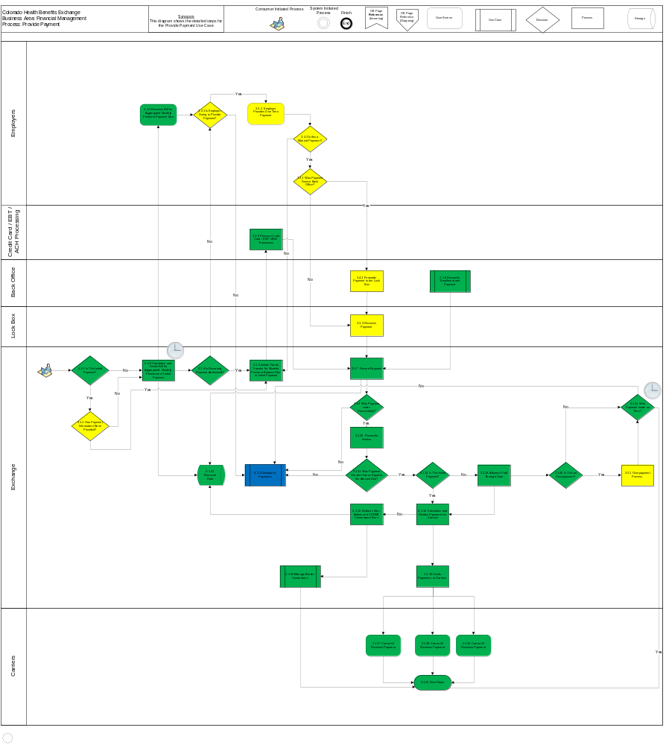

Basic (Main) Flow – Provide Payment
For initial payment where payment information has not yet been provided or when next billing cycle begins, the Exchange will calculate an aggregated bill for monthly premiums or initial payment owed by the Employer. A bill will be generated and sent to the Employer notifying it of the amount owed for that month’s premium or initial payment. The Exchange will then determine if the Employer has authorized recurring payments for its premiums. If so, the Exchange will initiate the funds transfer with the Employer’s credit card, EBT or ACH. The payment will be recorded in the Exchange and the Exchange will then determine if the payment was successful and if the payment was for an amount equal to the amount owed.

Is This Initial Payment?
The Exchange determines if the payment due is for an initial payment (Process Rule, Section 5.2.6).

Calculates and Sends Bill for Aggregated Monthly Premiums or Initial Payment
The Exchange calculates an aggregated bill for monthly premium due or initial payment from the Employer, depending on payment preferences, and the bill is sent to the Employer. The bill will be sent in a format based on user contact preferences (Business Rule, Section 5.1.1).

Receives Bill for Aggregated Monthly Premium Payment Due
The Employer receives the bill for aggregated monthly premium due from the Exchange.

Is Recurring Payment Authorized?
The Exchange determines if the Employer authorized recurring payments for monthly premiums (Business Rule, Section 5.1.2, Process Rule, Section 5.2.1).

Initiate Funds Transfer for Monthly Premium Balance Due or Initial Payment
The Exchange initiates a funds transfer for the Employer’s monthly premium balance due based on current enrollment or initial payment (Business Rule, Section 5.1.2).

Process Credit Card / EBT / ACH Transaction
The Credit Card / EBT / ACH Processing Entity processes the credit card / EBT / ACH transaction (Business Rule, Section 5.1.2).

Record Payment
The Exchange records the payment details of the Employer’s monthly premium payment (Business Rule, Section 5.1.3).

Reconcile Enrollment and Payment
The Reconcile Enrollment and Payment Use Case will handle the reconciliation of payments made to the Exchange (Business Rule, Section 5.1.3).

Was Payment Made Successfully?
The Exchange determines if the Employer’s payment was made successfully (Business Rule, Section 5.1.5, Process Rule, Section 5.2.2).

Reconcile Invoice
The Exchange updates the invoice amount to reflect any changes that have taken place after the original bill was produced for the monthly premium (Business Rule, Section 5.1.4). There may be cases where the Back Office needs to manually advance a paid-through date (e.g. disputes).

Was Payment Greater than or Equal to the Amount Due?
The Exchange determines if the Employer submitted a payment for an amount greater than or equal to what was due for the monthly premium (Business Rule, Section 5.1.5, Process Rule, Section 5.2.3).

Is This Initial Payment?
The Exchange determines if the payment provided by the Employer was for initial payment (Process Rule, Section 5.2.8).

Advance Paid-Through Date
The Exchange advances the paid-through date for the Employer indicating it has paid its premium due for the month (Business Rule, Section 5.1.5). There may be cases where the Back Office needs to manually advance a paid-through date (e.g. disputes).

Calculates and Divides Payments for Carriers
The Exchange calculates and divides up the payment received from the Employer to be sent to each Carrier (Business Rule, Section 5.1.6). As part of this calculation, the Exchange will deduct the fees owed to the Exchange. This will be one payment to each Carrier for all Employers.

Deducts User and Administrative Fees and COHBE Commission
The Exchange deducts User and Administrative fees and COHBE Commission from the premium provided by the Employer (Business Rule, Section 5.1.6).

Sends Payments to Carriers
The Exchange sends the payments due to each Carrier (Business Rule, Section 5.1.6). The Back Office may need to approve these payments.

Receives Payment
Carrier #1 receives monthly premium payment from the Exchange on behalf of the Employer (Business Rule, Section 5.1.6).

Receives Payment
Carrier #2 receives monthly premium payment from the Exchange on behalf of the Employer (Business Rule, Section 5.1.6).

Receives Payment
Carrier #3 receives monthly premium payment from the Exchange on behalf of the Employer (Business Rule, Section 5.1.6).

Is This an Overpayment?
The Exchange determines if the Employer made an overpayment for the monthly premium (Business Rule, Section 5.1.7, Process Rule, Section 5.2.4).

Was Payment Made on Time?
The Exchange determines if the monthly premium was paid on time by the Employer (Business Rule, Section 5.1.8, Process Rule, Section 5.2.5).

Manage Broker Commission
The Exchange will initiate the Manage Broker Commission Use Case.

Financial Data
The Exchange stores Invoice, Employer Payment, Carrier Payment and Administration fee data (Business Rule, Section 5.1.1)

Next Steps
Next steps for this Use Case include:
- When the next billing cycle begins, the Use Case repeats beginning at Step 2.1.1.
- For initial payment, the Exchange re-enters the Submit SHOP Application Use Case indicating payments were received successfully by the Carriers.

Alternate Flows

Has Payment Information Been Provided?
If the Exchange determines the payment due is for an initial payment, the Exchange will then determine if the Employer has provided its payment information during the Submit SHOP Application Use Case.

Has Payment Information Been Provided?
The Exchange determines if the Employer has provided its payment information for initial payment during the Submit SHOP Application Use Case (Process Rule, Section 5.2.7).

Employer Provides One-Time Automatic Payment
If the Employer did not authorize recurring payments during account creation, the Employer will have the option to provide a one-time payment to the Exchange for the monthly premium. Should the Employer choose to provide the payment, it provides an automatic payment (Credit Card / EBT/ ACH) to the Exchange.

Is Employer Going to Provide Payment?
The Employer decides if it is going to pay its monthly premium.

Employer Provides One-Time Payment
The Employer provides a one-time payment to the Exchange for its monthly premium.

Is This a Manual Payment?
The Employer makes its one-time payment either electronically or manually.

Employer Provides One-Time Manual Payment to the Lock Box
If the Employer did not authorize recurring payments during account creation, the Employer will have the option to provide a one-time payment to the Exchange for the monthly premium. Should the Employer choose to provide the payment, it provides a manual payment (Check or Cash) to the Exchange Lock Box.

Was Payment Sent to the Back Office?
If the Employer submitted a manual payment, the payment either gets sent to the Exchange’s lock box, the CGI Back Office or the COHBE Back Office.

Receives Payment
The Exchange Lock Box receives the Employer’s manual payment (Business Rule, Section 5.1.3).

Employer Sends One-Time Manual Payment to the Back Office
The Employer sends its manual payment (Check or Cash) to the Exchange Back Office instead of the Exchange Lock Box. The Back Office then forwards the manual payment to the Exchange’s Lock Box.

Forwards Payment to the Lock Box
The Exchange Back Office sends the Employer’s manual payment to the Exchange Lock Box.

Overpayment Process
Once the payment provided by the Employer has been deemed successful and the Exchange has determined that the amount of the payment is greater than the amount due, the Exchange will initiate the overpayment process.

Overpayment Process
The Exchange initiates the overpayment process (Business Rule, Section 5.1.7).

Exception Flows

Delinquent Payment Process
If the Employer has not authorized recurring payments for its monthly premiums and the Employer does not submit a payment after the invoice has been received, if the payment that was submitted was not deemed successful (e.g., Not Sufficient Funds or Credit Card not authorized), the payment was made late or the payment was made for an amount that was less than the minimum acceptable amount, the Exchange will initiate the Delinquent Payments Use Case.

Delinquent Payments Use Case
The Exchange initiates the Delinquent Payments Use Case, for initial and ongoing payments, when the Employer payment is not deemed successful (Not Sufficient Funds or Credit Card not authorized), when the Employer has not provided its payment, when the Employer has made an underpayment or when the Employer has not provided its payment on time (Business Rule, Section 5.1.5).

Specifications

Business Rules

Calculate and Send Aggregated Invoice
The Exchange calculates and sends to the Employer the aggregated invoice for initial payment when the Use Case is trigged by the Submit SHOP Application Use Case or for monthly premium payment due on the billing date of each month (Step 2.1.2). The invoice amount for ongoing monthly payment will reflect any changes made to the employee roster in the previous month. The Exchange will store and display twelve months of invoice data (Step 2.1.23).

Initiate Recurring Payment
When the Exchange determines that the Employer has authorized a recurring payment to be made (Step 2.1.3) for its monthly payment, the Exchange initiates a funds transfer (Step 2.1.5) with the Employer’s Credit Card / EBT Processing entity (Step 2.1.6).

Record Payment
After the Employer has provided the payment, either manual (Step 3.2.2) or automated (Step 2.1.4), the Exchange will record the payment details (Step 2.1.7). The Back Office will reconcile all payments made to the Exchange in the Reconcile Enrollment and Payment Use Case (Step 2.1.8).

Reconcile Invoice
After the Exchange has recorded the Employer’s payment (Step 2.1.7), the Exchange will determine if the amount paid by the Employer reflects any changes that took place after the bill was produced (Step 2.1.10). This may be due to changes to the Employer’s Employee roster. Any overpayment or underpayment resulting from this process will follow the processes described in this use case for overpayment or underpayment. For overpayment, a credit will be applied to the following month’s bill for that Employer’s account. For underpayment, the Delinquent Payments Use Case will be initiated. There may also be cases where the Back Office needs to manually advance an Employer’s paid-through date (e.g., in the case of a dispute).

Determine if Employer Payment is Acceptable
Once the Employer has provided its monthly premium payment and the payment details have been recorded in the Exchange (Step 2.1.7) , the Exchange will determine if the payment was successful (Step 2.1.9) and if the payment was for an amount greater than or equal to the amount due (Step 2.1.11) based on the reconciled invoice (Step 2.1.10). If the payment was successful and for an amount greater than the amount due and the payment is for ongoing payment (Step 2.1.12), the Exchange will advance the Employer’s paid-through date (Step 2.1.13). If the Employer’s premium payment was not made successfully, the Exchange will initiate the Delinquent Payments Use Case (Step 4.1.1). If the Employer’s payment was not greater than or equal to the amount due, the Exchange will initiate the Delinquent Payments Use Case (Step 4.1.1).

Calculate and Distribute Payments to Carriers
Once the Exchange has deemed the Employer payment to be acceptable, the Exchange will calculate and divide the payments due to the Carriers (Step 2.1.14), deduct User and Administrative fees and COHBE Commission (Step 2.1.15) and then send the payments to the Carriers (Step 2.1.16). The Carriers then receive the payments provided by the Exchange (Step 2.1.17, Step 2.1.18 and Step 2.1.19).

Determine if Payment was an Overpayment
Once the Exchange has deemed the Employer payment, for ongoing monthly payments, is greater than or equal to the amount due (Step 2.1.11) and the paid-through date has been advanced (Step 2.1.13) the Exchange will determine if the payment was an overpayment (Step 2.1.20). If the payment was an overpayment, the Exchange will initiate the Overpayment process which means the excess amount will be retained by the Exchange and a credit will be applied to the next month’s bill (Step 3.5.1).

Determine if the Payment was Made On Time
Once the Exchange has determined if the payment was an overpayment or not for ongoing monthly payments, the Exchange will determine if the payment was made by the due date (Step 2.1.21). If the payment was not made by the due date, the Exchange will initiate the Delinquent Payments Use Case (Step 4.1.1). If the payment was made by the due date, the Exchange proceeds to next steps (Step 2.1.24).

Process Rules

Is Recurring Payment Authorized?
After the Exchange has sent the invoice to the Employer for the monthly premium or initial payment (Step 2.1.2), the Exchange, based on the payment preferences set up by the Employer during account creation, will determine if a recurring payment has been authorized (Step 2.1.4).
- If Yes, proceed to Initiate Funds Transfer for Monthly Premium Balance Due or initial payment (Step 2.1.5).
- If No, proceed to Is Employer Going to Provide Payment? (Step 3.2.1).

Was Payment Made Successfully?
Once the Exchange has recorded the payment details for the payment provided by the Employer (Step 2.1.7), the Exchange will determine if the payment was successful (Step 2.1.9).
- If Yes, proceed to Reconcile Invoice (Step 2.1.10).
- If No, proceed to Delinquent Payments Use Case (Step 4.1.1).

Was Payment Greater than or Equal to Amount Due?
Once the Exchange has determined that the payment was made successfully (Step 2.1.9), the Exchange will then determine if the payment was greater than or equal to the amount due (Step 2.1.11) based on the reconciled invoice (Step 2.1.10).
- If Yes, proceed to Advance Paid-Through Date (Step 2.1.13).
- If No, proceed to the Delinquent Payment Use Case (Step 4.1.1).

Is This an Overpayment?
Once the Exchange has determined that the Employer’s payment was greater than or equal to the amount due, the Exchange will determine if the payment was an overpayment (Step 2.1.10).
- If Yes, proceed to Overpayment Process (Step 3.5.1).
- If No, Proceed to Was Payment Made on Time (Step 2.1.11).

Was Payment Made on Time?
After the Exchange has determined if the payment was an overpayment (Step 2.1.20), the Exchange will determine if the payment was made on time (Step 2.1.21).
- If Yes, the Exchange will proceed to Next Steps (Step 2.1.24).
- If No, the Exchange will initiate the Delinquent Payments Use Case (Step 4.1.1).

Is This Initial Payment?
The Exchange determines if the payment due is for an initial payment (Step 2.1.1):
- If Yes, proceed to Has Payment Information been Provided? (Step 3.1.1).
- If No, proceed to Calculates and Sends Bill/Statement for Aggregated Monthly Premiums or Initial Payment (Step 2.1.2).

Has Payment Information Been Provided?
The Exchange determines if payment information was provided during the Submit SHOP Application for initial payment (Step 3.1.1):
- If Yes, proceed to Initiate Funds Transfer for Monthly Premium Balance Due or Initial Payment (Step 2.1.5).
- If No, proceed to Calculates and Sends Bill/Statement for Aggregated Monthly Premiums or Initial Payment (Step 2.1.2).

Is This Initial Payment?
The Exchange determines if the payment provided by the Employer was for an initial payment (Step 2.1.12):
- If Yes, proceed to Calculates and Divides Payments for Carriers (Step 2.1.14).
- If No, proceed to Advance Paid-Through Date (Step 2.1.13).

Workflow

Forward Manual Payment
The Back Office, in the case where a manual payment is mailed to the Back Office, should forward the payment to the Lock Box and then record this in the activity log.

UI Screen Details

hCentive Payment Screen
This screen will allow the Employer to make a one-time automatic payment (Credit Card / EBT) to the Exchange if it has not authorized recurring payments for monthly premiums. This screen captures payment account data.

Communications

Imaging Requirements
There are no imaging requirements associated with the Provide Payment Use Case.

Form Requirements
There are no Form Requirements associated with the Provide Payment Use Case.

Notices Requirements
A notice containing the aggregated invoice for the monthly premium will be sent to the Employer.
Note: Notices required for Non-Payment, Partial Payment and Late Payment will be included in Delinquent Payment Use Case.

Other Communication Requirements
There are no other communication requirements for the Provide Payment Use Case.

Interfaces
Interfaces for this Use Case include:
- There will be an interface to a bank/clearinghouse to move funds.
- There will be an interface to the Carriers containing the 820 report.

Reporting
A report/reports will be needed to include the following information:
- Whether the Employer has made its payment.
- A breakdown by payment method used.
- Whether payment was made on time.
- Amount paid.
- Remaining balance.
- Open Invoices.
- Billing cycle data by date range for Employers at the Employee level.
- Overpayment including handling by the Exchange (refund, applied credit, etc..)
- Whether the Exchange paid the Carrier.
- Date payment was made to the Carrier.
- Amount Paid to the Carrier
- Policy Number

User Security
There are no additional user security requirements associated with the Provide Payment Use Case.

Activity Log and Audit Trail
There are no additional activity log and audit trail requirements for the Provide Payment Use Case.

Future Release Notes
There may be a generic notice around alternate payment methods.

Appendix A - Glossary
Term | Definition
Account | An “Account” is the means by which a user can access a computer system
Activity Log | An “Activity Log” is a chronological record of every action taken by each user, and by the System on behalf of each user. The activity log includes actions and events pertaining to transactions, workflow, security (including SIEM), Alerts, Notifications, Approvals and interactions between the user and the System such as submissions of forms, data and documents.
Audit Trail | An “Audit Trail” is a subset of records in the Activity Log that are selected and correlated by criteria provided by the auditor or requesting authority.
Authorization | “Authorization” is confirmation by a higher or secondary authority of the validity of an action taken by either a lower or primary actor of workflow on the System
Carriers | “Carriers” are providers of insurance who will sell Qualified Health Plans (QHPs) in the Exchange. Occasionally, the term Health Plans is used to mean Carriers. Where it is not clear if the term Health Plan means an offering of a Carrier or the Carrier itself, the context should be used to help clarify meaning. Carriers may also be referred to as “Issuers”.
COHBE | Colorado Health Benefit Exchange, “COHBE” is used interchangeably with “Exchange” throughout the documents.
Customer | “Customers” or “Consumers” may be used interchangeably and are terms meant to define individuals or small Employers or employees of small Employers learning about opportunities to purchase, shopping to purchase, purchasing insurance through the Exchange, or modifying insurance purchased through the Exchange. References to Customers include, as appropriate, dependents of Customers, employees and dependents of employees and others covered by insurance purchased by Customers through the Exchange.
DOI | The Colorado “Division of Insurance” regulates the insurance industry and assists consumers and other stakeholders with insurance issues.
DOI Authorization Standards | At this time Brokers are required to comply with the DOI Broker certification exam. Navigator’s authorization standards are TBD.
Employer | An “Employer” is a company or small business who participates in the Exchange to offer insurance and/or premium assistance to its Employee(s) or its Employee(s) and their dependents.
Exchange | During the implementation phase, the terms “Exchange” or “Exchanges” are meant to include technology, services, business processes, people, and other resources required to implement, operate and/or maintain the requirements or functions needed to support the ability for consumers to shop for and purchase health insurance. Specifically related to interpretation of a requirement, the term “Exchange” implies that the implementation of a requirement is not strictly limited to a technology solution.  - Individually, the term “Exchange” refers to each Exchange or both Exchanges as appropriate in the context.  - The Exchange is NOT a state agency but a standalone non-profit entity. It will serve as an aggregator of individual policies sold by private insurers and underwritten using the new federal and state underwriting and rating rules.  - The Small Business Health Options Program (SHOP) Exchange will support the specific needs of small Employers.  - For context, the Exchanges will act much like an “Expedia or Orbitz for Health Insurance” system. They will allow individuals and small firms to obtain information, compare and purchase private health insurance plans. The Exchanges will also be the entities that will evaluate whether or not a particular insurance policy meets the criteria set out by the new federal rules for policies offered to individuals and small Employers.
Escalation | “Escalation” shall mean re-assignment by the System or a user of the System of an action to a higher authority.
Brokers | “Brokers” are persons authorized to assist Employers and or Individuals in their activities to shop for insurance through the Exchanges.
Lock Box | A “Lock Box” is a service offered to organizations by commercial banks that simplifies collection and processing of account receivables by having those organizations' customers' payments mailed directly to a location accessible by the bank.
System | The “System” means all of the software, configurations, data, processes, and equipment used to provide the Exchanges and the System is also referred to as the “solution.” During the implementation phase, “System” is taken to mean the technology component of the Exchange.
Users | “Users” are users of the Exchange authorized by COHBE and may include operators, administrators, customers, brokers, navigators, etc., who interact with the System. Users may be internal or external to COHBE.

